Snipe of terraform creation of infrastructure:  
  
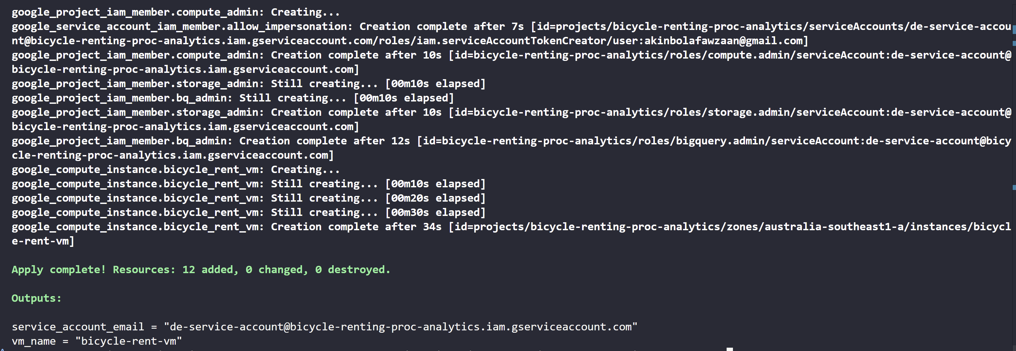

These are what we provisioned and accomplished with this terraform tool  
You’ve now got:

* APIs enabled
* Service account + IAM roles set
* VM running
* Storage bucket created
* BigQuery dataset ready

BUT before we ran the main.ft file we made sure our CLI can

1. access our google account using: gcloud auth application-default login
2. can access our project using: gcloud config set project bicycle-renting-proc-analytics

NOTE google SDK must have been installed